Mandatory Reporting
This module is designed to develop service providers’ understanding of West Virginia law regarding mandatory reporting of sexual violence against adults who are considered “incapacitated.”
Key Points
• In West Virginia, designated persons are mandatory reporters of suspected abuse or neglect of adults who are incapacitated, or of emergency situations where adults who are incapacitated are at imminent risk of serious harm. These persons include: medical, dental and mental health professionals; Christian Science practitioners; religious healers; social service workers; law enforcement officers; humane officers; state or regional ombudsmen; and employees of nursing homes or other residential facilities.
• Abuse, neglect or an emergency situation involving an adult who is incapacitated should be reported to the local Department of Health and Human Resources (DHHR), Adult Protective Services (APS), or the 24-hour hotline provided for this purpose (800-352-6513). If you suspect a crime has been committed, contact the local law enforcement agency. If you are uncertain, you can contact law enforcement and they, in turn, may direct you to DHHR/APS.
• When you call DHHR to make a report, be prepared to provide (as it is available) the name, address and phone number of the alleged victim; name, address and phone number of the alleged perpetrator; your name, phone number and address (although anonymous reports are accepted); information on the physical, cognitive and emotional functioning of the victim and the perpetrator; and the reason for your concern.1
• The initial verbal report to DHHR should be followed within 48 hours with a written report. DHHR’s APS Mandatory Reporting Form can be used for this purpose or your agency can use its own form. In addition, copies of the report are to be distributed by the reporter to various parties (law enforcement/prosecution, ombudsman program, OHFLAC, long-term care facility administration, and/or medical examiner/coroner), depending on the circumstances of the allegations.

B5. Mandatory Reporting
Purpose
It may not always be clear to service providers who work with individuals with disabilities if they are mandated by law to report sexual violence, which situations require a report, to whom they are required to report and how to go about reporting. This module is designed to develop service providers’ knowledge of West Virginia law regarding mandatory reporting of sexual violence against adults who are considered incapacitated. For purposes of mandatory abuse reporting, an adult is considered “incapacitated” when s/he cannot independently conduct daily life sustaining activities due to a physical, mental or other infirmity.2
This module also encourages discussion on how to ensure that agency staff members have a full understanding of what the law mandates, including timelines for reporting, under what circumstances to report and the reporting procedures. (For supplemental information on this topic, see Sexual Violence 101. Confidentiality and Disability 101. Guardianship and Conservatorship.)
Given that the definition of “incapacitated adult” for mandatory reporting is very broad, including physical and mental infirmities, it is important to be very clear that this definition only applies under the mandatory reporting laws. The definition of “incapacitated adult” may be different, and more narrow, in other contexts.
Objectives
Those who complete this module will be able to:
• Discuss state mandated provisions for mandatory reporting and identify who are considered mandatory reporters of abuse, neglect or an emergency situation3 involving individuals the state refers to as “incapacitated adults;”
• Determine if they are mandatory reporters and how to make a report;
• Understand the process for submitting their agency’s West Virginia APS mandatory reporting form;
• Discuss policies and practices regarding mandatory reporting of different partnering agencies; and
• Discuss ethical issues related to mandatory reporting and the consequences of non-compliance for mandatory reporters.

Part 1: CORE KNOWLEDGE
What is a mandatory reporter?
For the purpose of this module, “mandated reporters” refers to professionals who, in the course of their work, are required to report or cause a report to be made whenever mistreatment of an adult who is incapacitated has been observed or is suspected, or if an adult who is incapacitated is at imminent risk of serious harm.4
Mandated reporters are designated by law to help protect persons who may not be able to protect themselves. Mandated reporting is a complicated issue, since all professionals are not well trained on this issue. First and foremost, you need to talk with your supervisor and determine if you are a mandated reporter under West Virginia law.
What state laws relate to mandatory reporting of incidents of sexual violence involving adult victims who are incapacitated?5
In addition to the general provisions related to the reporting of abuse, neglect or an emergency situation involving an adult who is incapacitated, the West Virginia Code (WVC§9-6-9) also identifies various individuals who are mandatory reporters.6 If any of these individuals believe, suspect or know that an adult who is incapacitated is being subjected to, or has the potential to be subjected to abuse, neglect or an emergency situation, they must immediately report the circumstances to the local DHHR. The following are identified as mandatory reporters:
• Medical, dental and mental health professionals;
• Religious healers and Christian Science practitioners;7
• Social service workers, including those employed by the DHHR;
• Law enforcement officers;
• Humane officers;8
• State or regional ombudsmen;9 or
• Any employee of a nursing home or other residential facility.
These requirements apply without regard to where victims reside (e.g., their own home, home of another individual or an institutional/facility setting). As stated in WVC§9-6-14, failure to make such a report can be punishable by a fine of up to $100 or imprisonment of up to 10 days. Note also that reporters are provided with immunity from civil or criminal liability if the suspected sexual assault/abuse is unsubstantiated.10
FYI—Sexual violence victims, as well as their families and caregivers, may be reluctant to report. Keep in mind that the safety of victims is your primary responsibility and the reason you are required to report. It is good practice to explain your reporting requirements to victims during your initial interactions with them so they fully understand their options for assistance as well as possible unintended repercussions that could result from reporting.11 To the extent possible, help address any concerns they may have about reporting (e.g., fear of placement in an assisted living facility).
FYI—This module focuses on adults with disabilities who are incapacitated. As detailed in the next section, the reporting process for adult victims differs from cases of suspected or observed mistreatment of a minor, for which mandatory reporters in West Virginia (according to WVC §49-6A-2) include: medical, dental or mental health professionals, religious healers and members of the clergy, Christian Science practitioners, social service workers, school teachers and other school personnel, child care or foster care workers, humane officers, emergency medical services personnel, peace officers or law enforcement officials, circuit court and family court judges, employees of the Division of Juvenile Services and magistrates.12 The 24-hour hotline number to report child abuse and neglect is the same as the hotline for reporting adult abuse and neglect (800-352-6513).
What are the procedures for making a mandated report?
Reports of abuse or neglect involving an adult who is incapacitated should be made directly to the local DHHR/APS13 or the 24-hour hotline that is provided for this purpose—800-352-6513 (use the hotline especially after regular business hours).
FYI—If you are a mandated reporter and suspect abuse or neglect of an adult who is incapacitated, you are required to report to your local DHHR/APS or the state DHHR hotline. If you suspect a crime has occurred, call the local law enforcement agency. If you are not certain of which agency to involve, you can always call law enforcement first. They, in turn, may direct you to DHHR/APS.
FYI—Your obligation to report only needs to be based on a suspicion of mistreatment. Your suspicion may be based on a disclosure by a victim or your observations of a pattern of indicators associated with mistreatment (e.g., physical signs of a sexual assault, sudden changes in behavior, emotional distress, etc.). It is not your role to verify that mistreatment is occurring or has occurred. If you question whether a report should be made, discuss the circumstances of the case with your supervisor. You can also call DHHR or law enforcement and, without giving the identifying information on the case, describe the situation and ask if it warrants a report. (See Sexual Violence 101. Indicators of Sexual Violence.)
When you call DHHR to make a report, you will be asked to provide the following information (to the extent that it is available):
• Name, address and phone number of the victim;
• Identifying information of the victim such as: date of birth, social security number, age and ethnicity;
• Name, address and phone number of the alleged perpetrator;
• Identifying information of the alleged perpetrator, including the nature of the relationship between the victim and the perpetrator;
• Your name, phone number and address (West Virginia permits anonymous reporting; however, it is helpful if the agency receiving the report has your contact information in case additional information is needed);
• Information, if applicable, on the physical, cognitive and emotional functioning of the victim and the perpetrator; and
• The reason for your concern (e.g., type of sexual violence and injuries incurred).
If you do not know the answer to a question, say so. Do not guess.
Do mandatory reporters have any other obligations beyond making a verbal report to DHHR?
Individuals who are mandated to report suspected or known cases of abuse, neglect or emergency situations must follow their initial verbal report to DHHR with a written report. This written report must be submitted to the local DHHR within 48 hours following the verbal report. Each agency should have a form for reporting to DHHR. A sample APS Mandatory Reporting Form, created by DHHR, can be used (a copy of this form can be found at the end of this module).
In addition to the submission of this report to DHHR, the reporter is to distribute copies to various parties, depending on the circumstances of the allegations:
• If the victim is a resident of a nursing home or other residential facility, submit a report to a state/regional ombudsman,14 the Office of Health Facility Licensure and Certification (OHFLAC)15 and the facility administrator;
• In the case of the death of the victim, submit a report to the local medical examiner or coroner;
• If abuse or neglect is believed to have been a contributing factor to the death, also submit the report to law enforcement; and
• In the case of a violent crime, sexual assault, domestic violence, murder, etc., submit a report to law enforcement and the prosecuting attorney.
FYI—Beyond sharing copies with the above parties as appropriate given the circumstances of the allegation, DHHR reports of abuse, neglect or emergency situations involving an adult who is incapacitated are confidential (including the identity of the reporter) and are not to be released unless court ordered.16 If the referent later seeks status information about the case, DHHR can only inform the referent that it “is taking appropriate action.” DHHR cannot tell the referent whether an investigation has been initiated or is underway.
Test Your Knowledge
Refer to the pages in this module as indicated to find the answer to each question.
1. How does West Virginia law define an adult who is incapacitated? See page B5.1.
2. Who does West Virginia law identify as mandatory reporters? See page B5.3.
3. What agency takes reports of suspected abuse, neglect or emergency situations involving adults who are incapacitated? What is the 24-hour hotline number provided for this purpose? See page B5.3.
4. What information is needed to make a report? See page B5.4.
5. What obligations do reporters have once a verbal report is filed? See pages B5.4—B5.5.
Part 2: DISCUSSION
Projected Time for Discussion
1.25 hours
Purpose and Outcomes
This discussion is designed to help participants apply information presented in Part 1: Core Knowledge of this module to their collaborative work with sexual violence victims. The discussion could be incorporated into forums such as agency staff meetings, orientations and continuing education programs, as well as multi-agency meetings or trainings. Anticipated discussion outcomes include an increased understanding of mandatory reporting and related practices and processes in your community.
Refer to the learning objectives at the beginning of this module for specific outcomes for this module.
Planning
• Ensure that the meeting is held at an accessible location. Ask participants prior to the meeting if they need any accommodations—if so, work with them to secure accommodations.
• Select a facilitator. The facilitator should be familiar with mandatory reporting laws related to the sexual assault and sexual abuse of incapacitated adults.
• Select a note taker.
• Participants and the facilitator should review Part 1: Core Knowledge of this module before the discussion, as well as the copy of the APS Mandatory Reporting Form at the end of the module.
• Each participant should bring to the meeting:
o A copy of their agency’s policy/philosophy regarding mandatory reporting or information describing how the agency promotes compliance with this law, and their agency’s APS mandatory reporting form (if different from the one developed by DHHR).
o A copy of any training materials the agency uses to educate staff on mandatory reporting laws, protocols and policies.
• Bring the following supplies and materials to the meeting: flipcharts and colored markers, blank attendance sheet, sufficient copies of participant materials, office supplies (tape, pens, paper, etc.) and a clock/watch to monitor time. Optional items include name badges or table tents.
Suggested Activities and Questions
1. Invite participants to identify discussion ground rules to promote open communication. Utilize the following principles: (10 minutes)
• An environment of mutual respect and trust is optimal. Everyone should feel comfortable expressing their opinions and feelings about the various topics.
• Avoid personalized comments that are negative as they can lead to defensiveness and confrontation among participants and ultimately may shut down dialogue.
• Be clear about what information discussed during this meeting is confidential and what the expectations are for confidentiality in the context of this partnership.
2. Ask a representative from each partnering agency to share the policies, reporting forms and training materials they brought to the meeting and summarize their contents. (10 minutes)
3. As a large group, discuss the following questions: (45 minutes)
a. Why is there a need for mandatory reporting?
b. Who are mandatory reporters in West Virginia? Do you identify yourself as a mandatory reporter? What are you mandated to report? What discomfort do you feel, if any, associated with being a mandatory reporter?
c. Do procedures for reporting suspected abuse or neglect of an adult who is incapacitated differ across agencies? If yes, how?
d. What are the timelines for reporting?
e. How can agencies insure that all staff members and volunteers are responding appropriately to reporting mandates?
f. What strengths and weaknesses exist in the current service delivery systems regarding mandatory reporting that may affect victims of sexual violence?
g. What are the some of the ethical issues surrounding mandatory reporting? What are the potential implications or unintended consequences for reporting suspected incidences of sexual violence?
h. What policy and/or practice changes can be made within each partnering agency to maximize compliance with this law? What specific steps need to be taken to facilitate those changes?
4. Closing. Ask each participant to write down how the information gained from this module discussion will:
• Change the way they interact with individual clients;
• Change the way they partner with other agencies to assist clients; and
• Promote change in their agency’s policies, practices or training programs.
Then facilitate a large group discussion on this topic. (10 minutes)

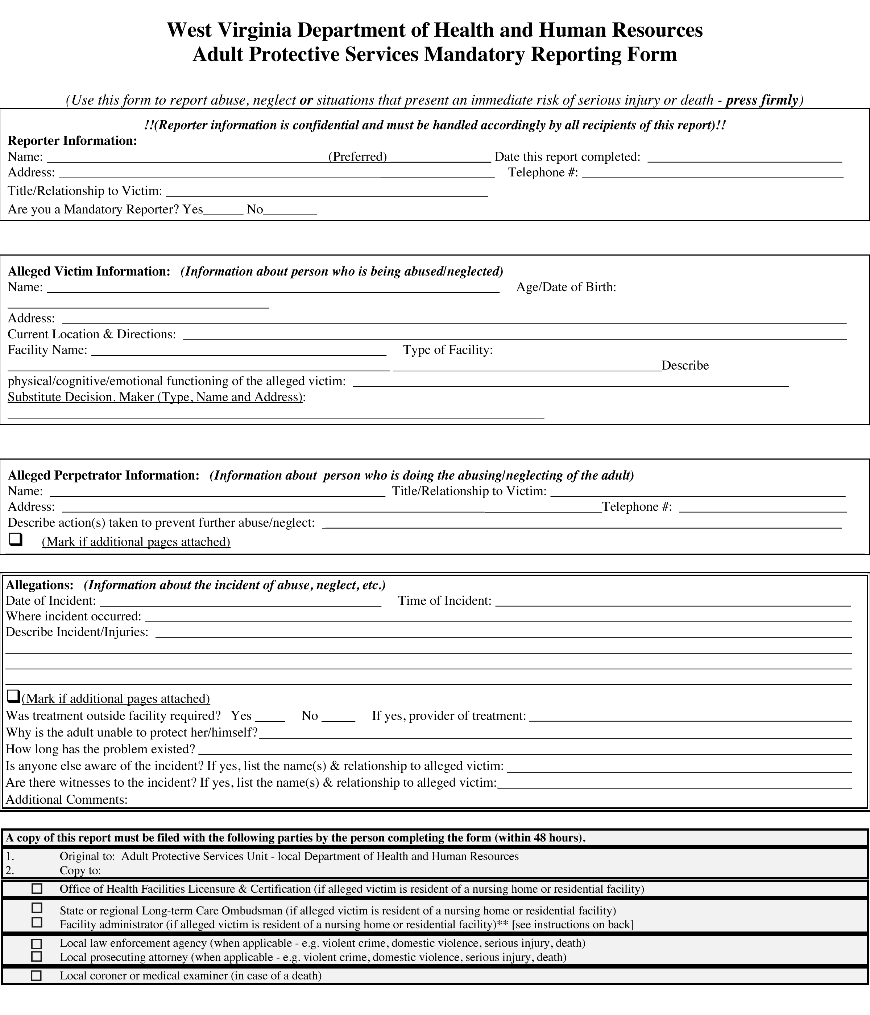

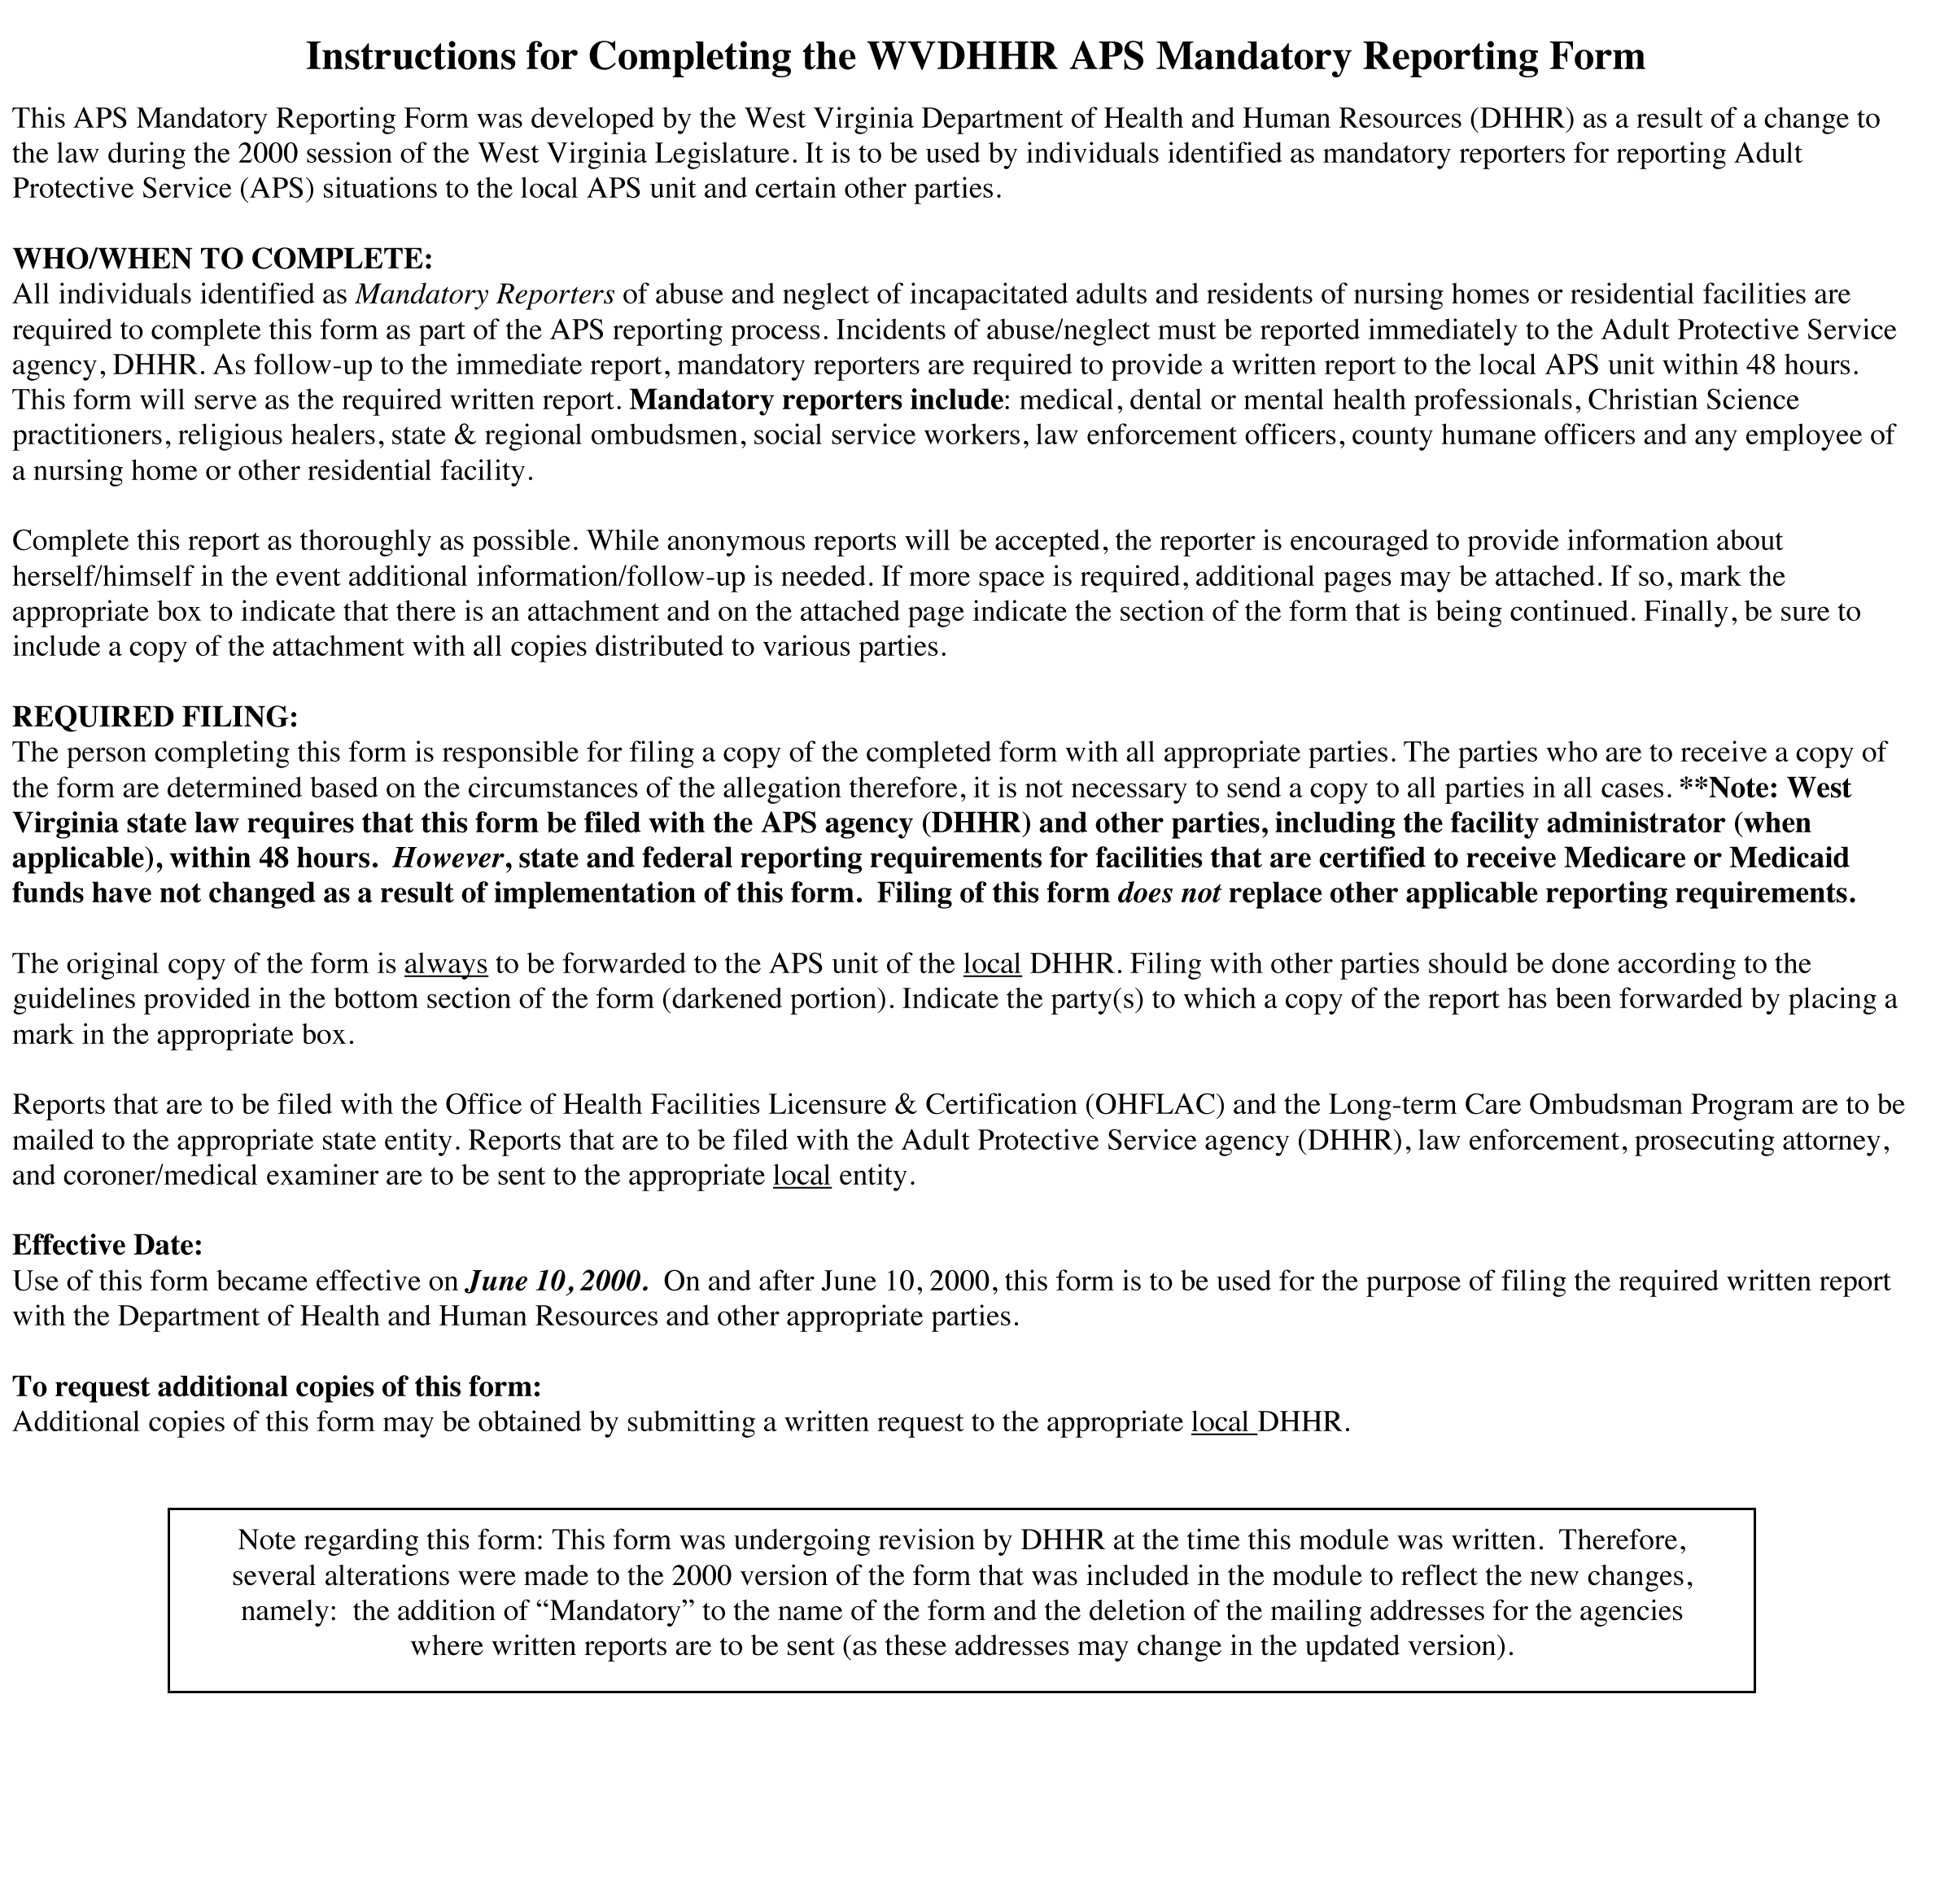
Project partners welcome the non-commercial use of this module to increase knowledge about serving sexual violence victims with disabilities in any community, and adaptation for use in other states and communities as needed, without the need for permission. We do request that any material used from this toolkit be credited to the West Virginia Sexual Assault Free Environment (WV S.A.F.E.) project, a partnership of the West Virginia Foundation for Rape Information and Services, the Northern West Virginia Center for Independent Living and the West Virginia Department of Health and Human Resources (2010). Questions about the project should be directed to the West Virginia Foundation for Rape Information and Services at www.fris.org.

Funding was provided by Grant No. 2006-FW-AX-K001 awarded by the Office on Violence Against Women, U.S. Department of Justice. The opinions, findings, conclusions and recommendations expressed in this module are those of the authors and do not necessarily reflect the views of the U.S. Department of Justice, Office on Violence Against Women.

1Partnering agencies refer to the persons they serve as “clients,” “consumers” and “victims.” For convenience, the term “victims” is primarily used in this module. Also note that the terms “sexual violence” and “sexual assault” are generally used in this module to encompass sexual assault, sexual abuse and other forms of sexual violence.
2As per WVC§9-6-9. See http://www.legis.state.wv.us/WVCODE/Code.cfm for all code references. Note that this and all other online documents referenced in this module were available at the links provided at the time the module was written. It is suggested you check the sites for any updates or changes. If you experience difficulty accessing the documents via the links, another option for locating the documents is doing a web search using titles.
3As per WVC§9-5-9, “emergency” or “emergency situation” means a situation or set of circumstances which presents a substantial and immediate risk of death or serious injury to an adult who is incapacitated.
4Adapted from Wikipedia, http://en.wikipedia.org/wiki/Mandatory_reporting.
5The following information on mandatory reporting was excerpted/drawn from the West Virginia Department of Health and Human Resources Adult Protective Services Manual.
6See WVC§9-6-9, http://www.legis.state.wv.us/WVCODE/Code.cfm.
7“Many states and territories include Christian Science practitioners or religious healers among professionals who are mandated to report suspected child maltreatment [and often mistreatment of vulnerable adults]. In most instances, they appear to be regarded as a type of health care provider.” Reporting laws: Clergy as mandated reporter (National Clearinghouse on Child Abuse and Neglect Information, 2003), http://www.churchlawtoday.com/private/library/cltr/rrclergyreportinglaws.html. “Christian Science practitioners provide spiritual treatment through prayer that results in healing.” “Treatment is based on the Bible, and the principles explained in Science and Health with Key to the Scriptures by Mary Baker Eddy. Central to this treatment is the idea of one, all-good God, who loves and cares for each of us.” Healing (Christian Science), http://christianscience.com/.
8WVC§7-10-1: In West Virginia, the sheriff of each county annually designates one of his or her deputies to act as humane officer of the county; or, if the county commission and sheriff agree, the county dog warden may be designated to act as the humane officer or as an additional humane officer. A humane officer investigates complaints of cruel or inhumane treatment of animals within his or her county and enforces the law relating to the prevention of cruelty to animals.
9An ombudsman is an advocate for residents of nursing homes, board and care homes, and assisted living facilities. Ombudsmen provide information about how to find a facility and what to do to get quality care. They are trained to resolve problems. The ombudsman can assist residents with complaints. However, unless the resident gives the ombudsman permission to share his/her concerns, these matters are kept confidential. Under the federal Older Americans Act, every state is required to have an ombudsman program that addresses complaints and advocates for improvements in the long-term care system. National Long-Term Care Ombudsmen Resource Center, http://www.ltcombudsman.org/.
10WVC§9-6-12 (a): Any person who in good faith makes or causes to be made any report [of mistreatment of an incapacitated adult as defined by West Virginia law] permitted or required by this article shall be immune from any civil or criminal liability which might otherwise arise solely out of making such report.
11For example, there have been instances (1) where victims of domestic violence have lost custody of their children as an indirect result of reporting their victimization to law enforcement; and (2) where victims who are in the country illegally have been deported after a report of abuse. These practices are not typical and are even discouraged in many jurisdictions, but nonetheless, they have occurred.
12DHHR website on reporting child abuse and neglect, http://www.wvdhhr.org/bcf/children_adult/cps/report.asp. The list of mandatory reporters for minors is slightly different from that for adults who are incapacitated; each list reflects the helping professionals that typically might have contact with that population.
13Go to WV APS, http://www.wvdhhr.org/bcf/children_adult/aps/default.asp, for local DHHR contact information.
14Call 800-834-0598 to speak with a West Virginia ombudsman. Go to http://www.wvseniorservices.gov/ and click on “Staying Safe” for a description of the state administered long-term care ombudsman program and to access contact information for ombudsmen.
15Call OHFLAC at 304-558-0050. Go to http://www.wvdhhr.org/ohflac/ for more information about this DHHR-administered office.
16WVC§9-6-8: In addition to DHHR/state protective agencies, these confidentiality requirements are in place for state and regional long-term care ombudsmen, nursing home or facility administrators and OHFLAC.

